**Lesson 5 Demo 6**

**Remote Triggering of a Parameterized Build**

**Objective:** Trigger parameterized builds in Jenkins remotely

**Tools required:** Jenkins

**Prerequisite:** Please ensure you have jenkins installed in order to proceed. In case you don’t have it installed, you can refer to demo 1 of lesson 5 to install jenkins.

Steps to be followed:

1. Configure a parameterized build in Jenkins
2. Trigger a parameterized build remotely

**Step 1: Configure a parameterized build in Jenkins**

* 1. Open the browser and go to **Jenkins dashboard** by typing **localhost:8080** in your browser.

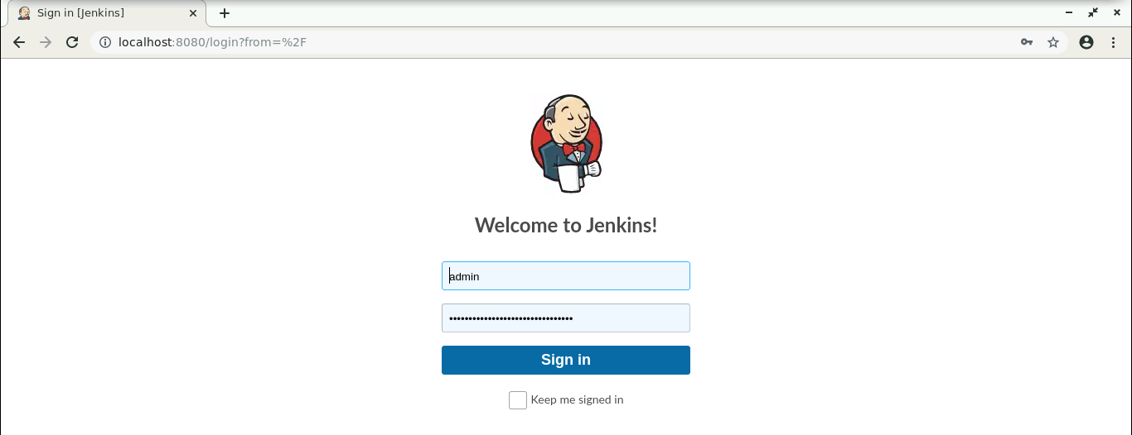

* 1. Provide the credentials and click on **Sign in**.
  2. Click on **Manage Jenkins**. From the list of options, choose **Manage Plugins**.

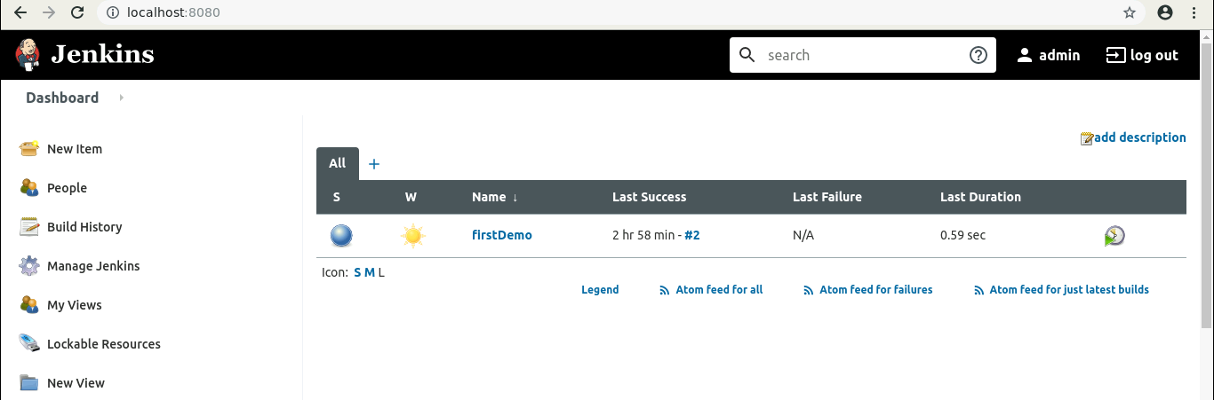

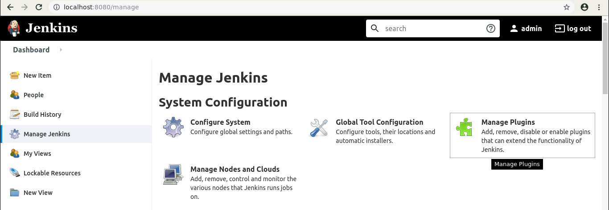

* 1. Under the **Available** tab, search for **Build with Parameters** Plugin. 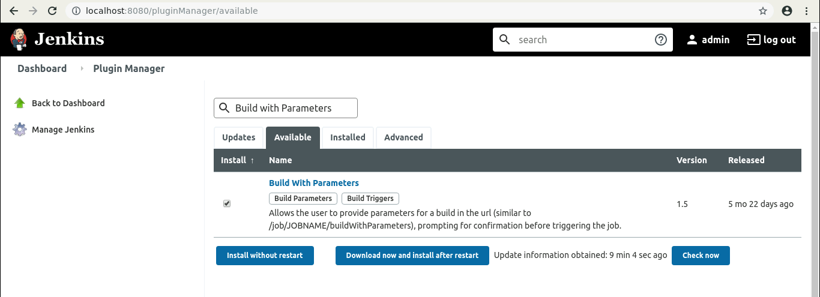
  2. Select the checkbox in front of the **plugin**and click on the **Install without restart** button.

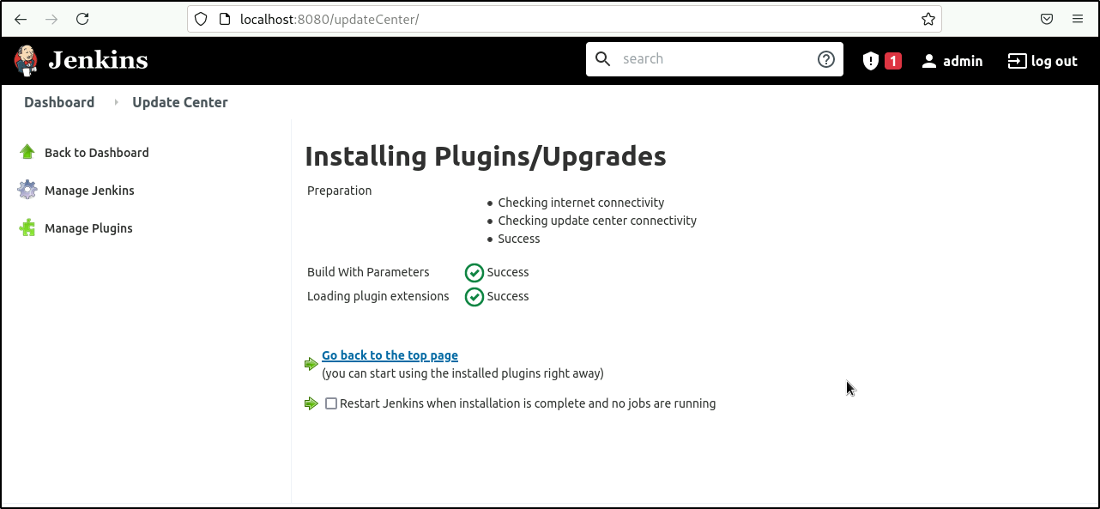

* 1. Go to the Jenkins Dashboard, click on **New Item** in the Jenkins dashboard.

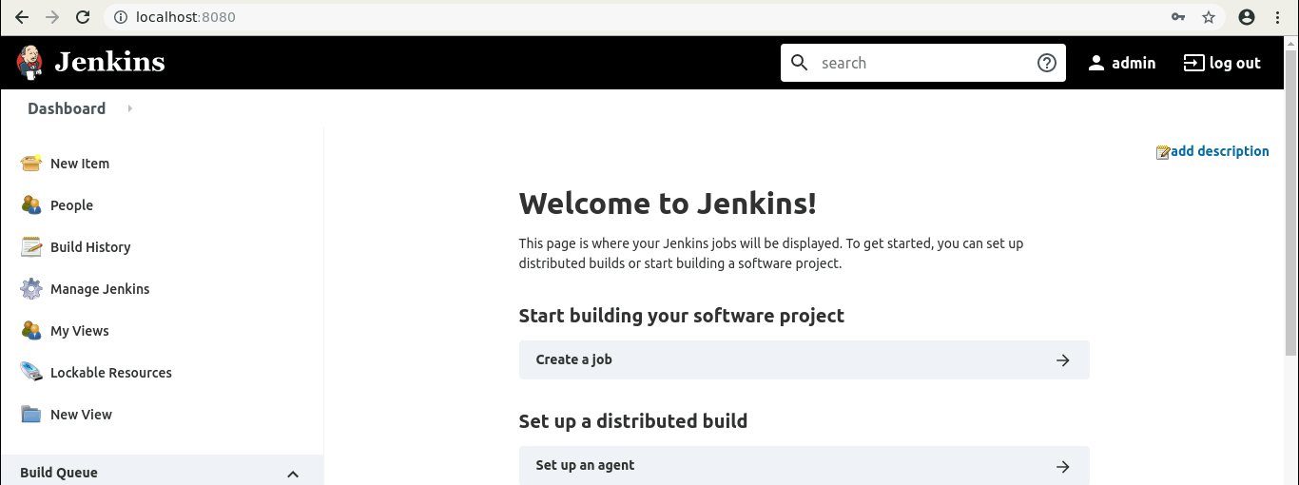

* 1. Enter a name for your project.
  2. Select the **Freestyle project** as the build job type.

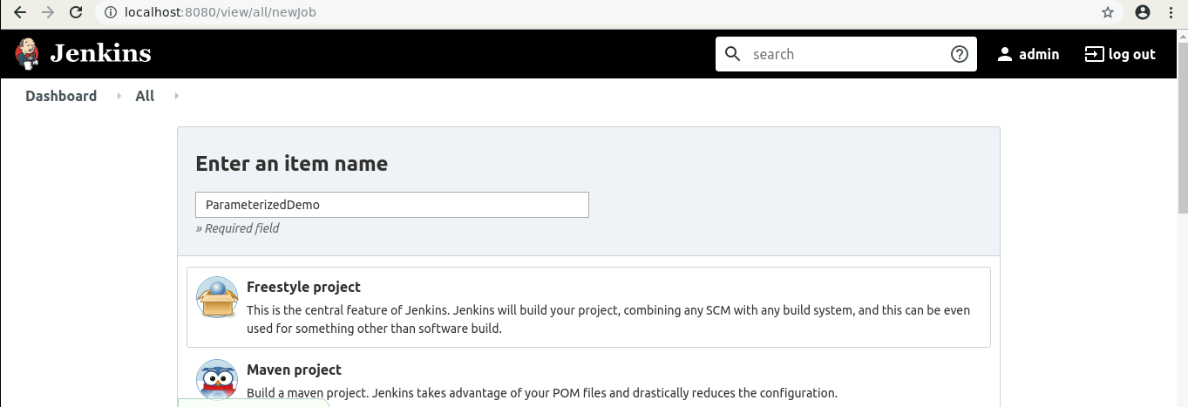

* 1. Click on **OK**.
  2. On the configuration page, select the checkbox next to text that states,**This project is parameterized.**
  3. Click on the **Add parameter** button that appears.

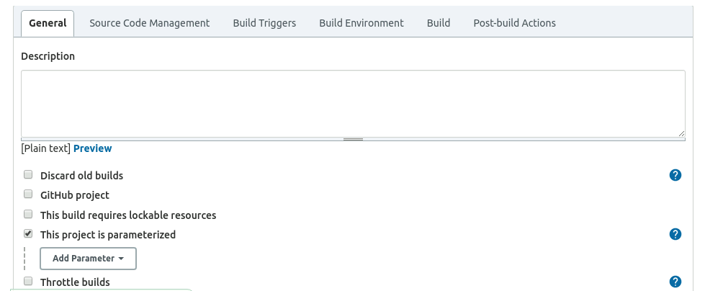

* 1. From the drop-down menu that appears, select **String Parameter**.

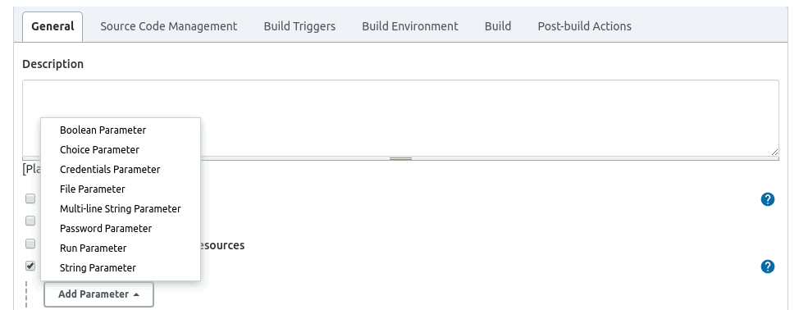

* 1. Enter the Name of the parameter as **my_param**, and enter the **Default Value*.*** *(Ex: hi)*.

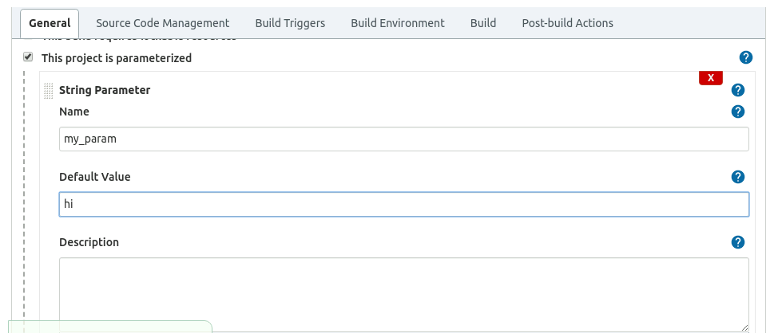

* 1. Under the Build Triggers section select **Trigger builds remotely** and type **Sam** as the token value.

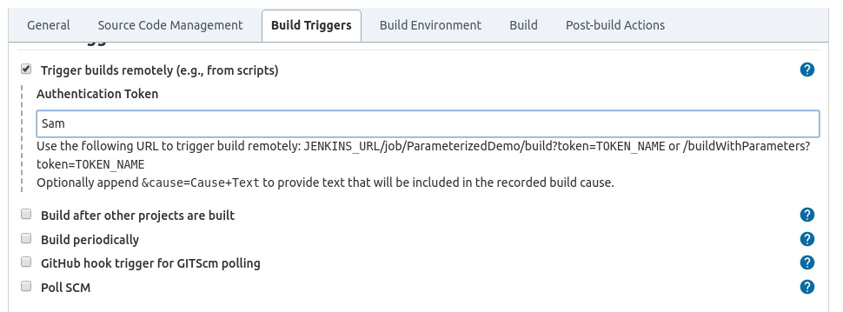

* 1. Scroll down to the **Build** section and click on **Add build step**.
  2. Select **Execute Shell Command** from the drop down that appears.

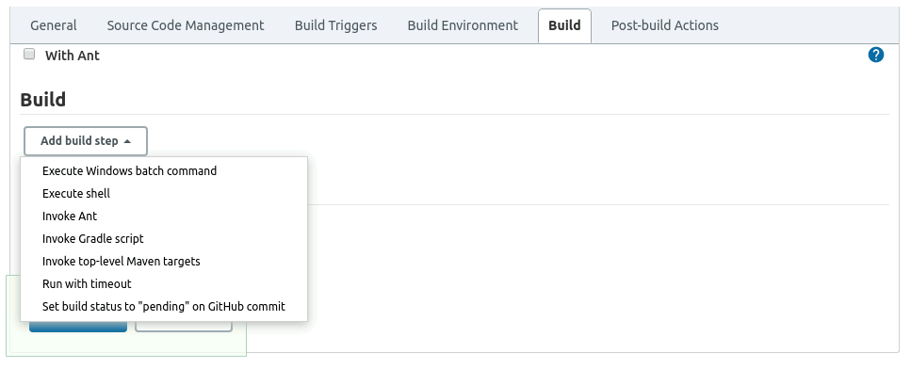

* 1. In the text input area that appears, enter the following text:

***echo $my_param***

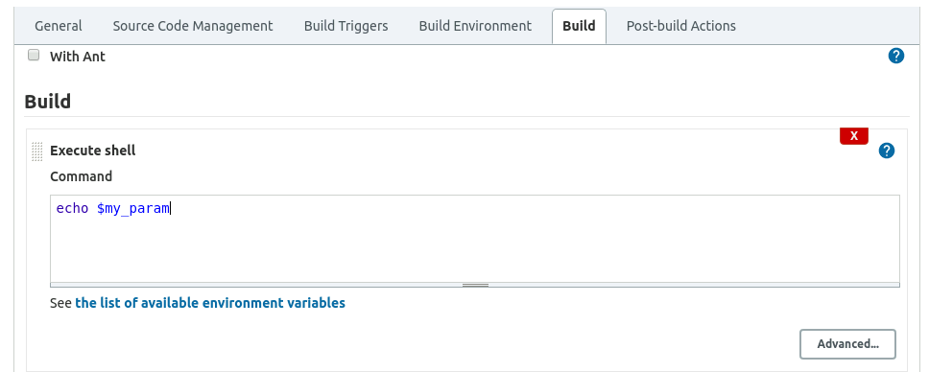

* 1. Click **Save**.

**Step 2: Triggering a parameterized build remotely**

* 1. Copy the **URL** to the job from the project window.

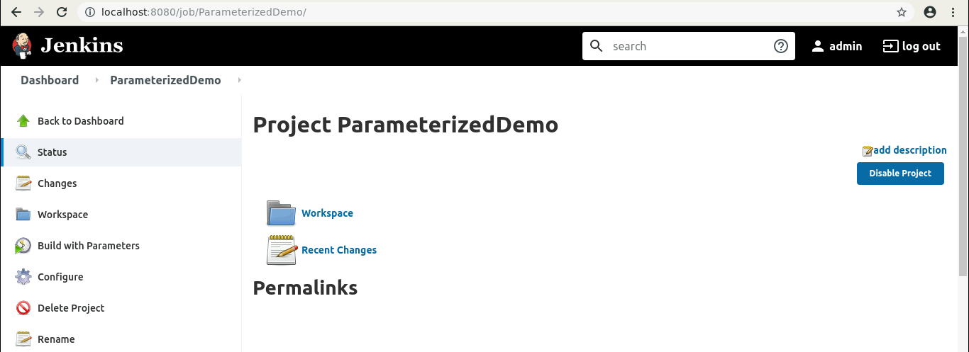

* 1. Open the terminal.
  2. Suffix the parameter and its value to the URL copied in the previous step and send a *GET* request using *Curl*.

***curl -X GET <YourJenkinsJobUrl>/buildWithParameters?token=Sam***

**

**Note:** In case you get an authentication error, check your security settings in **Manage jenkins** > **Configure Global Security** . It should be configured as shown below:

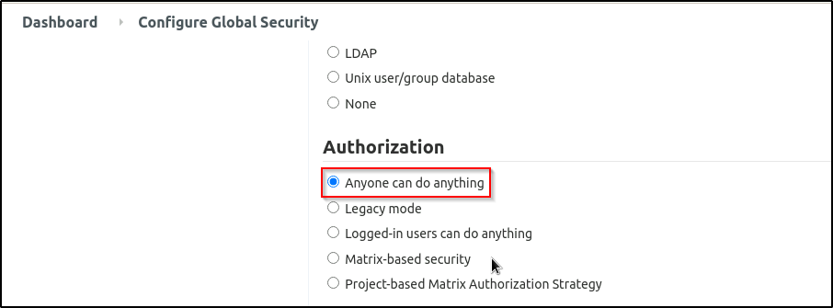

* 1. Open the **job** in the Jenkins UI.
  2. Click on the **Build History**to view the build results.
  3. Click on the **Console Output** to view the build logs.
  4. The parameter value will be displayed in the console output.

